Probabilistic Per-Dimension Drift Scoring
Oct 24, 2026 · @Dev

The idea
Instead of one overall "good or bad" verdict, a probabilistic model scores each specific aspect of an agent's action on its own: how likely is this, given this agent's role?
Example for a Procurement Agent:
Dimension | Action observed | P(normal for role)
Tool or API called | Supplier price API | 0.97
Data resource | HR salary files | 0.001
Destination | Unknown external server | 0.002
Data volume | 500 MB | 0.01
Action sequence | Read PDF, then read HR files, then send data out | 0.003
Time and frequency | Normal working hours | 0.90
The alert then explains itself: risk 96 out of 100, because the agent accessed HR data (0.1% likely for this role) and sent data to a never-seen destination (0.2% likely). That is the clear, explained risk score the problem statement asks for.

How to build it simply
The scorer needs four parts, and each is small enough for a hackathon build.
- Per-dimension distributions. Learn from each role's history, using frequency tables or small models for tool, resource, destination, volume and timing.
- A sequence model on top. A Markov chain or small sequence model catches combinations that look fine alone but are suspicious together, such as reading sensitive data and then sending outbound.
- One combined risk score. Sum the negative log-probabilities, or weight the dimensions. Give data access and outbound destinations more weight than time of day.
- A weakest-link rule. One extremely unlikely dimension, like exfiltration to a new domain, should raise an alert even if the other five look normal, so averaging cannot hide it.

Things to watch out for
Five risks decide whether the scorer works in practice.
Risk | What goes wrong | Mitigation
Rare but legitimate actions | A real but infrequent action gets a low probability and triggers a false alarm | Use smoothing, and send low-probability actions to a step-up approval tier instead of auto-blocking
Cold start | A new agent has no history to learn from | Initialize the distributions from the declared role (allowed tools and data scopes) and from peer agents with the same role, then update as real behavior arrives
Slow drift | If the baseline keeps updating from the agent's own behavior, an attacker can shift it gradually | Update slowly, and keep a frozen reference built from the role definition to compare against
Hard rules first | Some actions should never depend on a probability | Block them deterministically in the harness (for example HR data for a procurement agent, or non-allowlisted outbound domains) and use probabilities for the gray area
Calibration | A "0.1% likely" score that does not match how rare the behavior really is gives meaningless thresholds | Test the scores against known normal and abnormal behavior, so the thresholds mean something and false alarms stay manageable

Where it fits in the original sketch
The scorer replaces the judge box in the original sketch and runs on actions before they execute, not only on final responses.
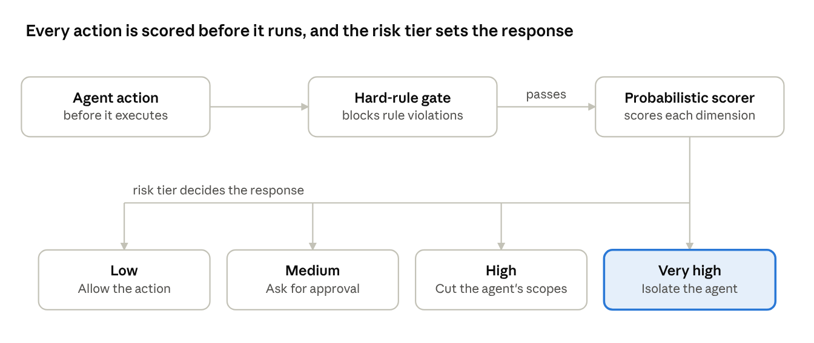
action scoring and response ladder · 3 stages, 4 risk tiers
The retry loop becomes a response ladder: low risk is allowed, medium needs step-up approval, high loses scopes, and very high is isolated.

Next step
Build a small Python prototype with fake agent logs and per-dimension scoring, so the team has something to demo.

